MORNING WORSHIP SERVICE
Dec 20, 2015

Opening Song “O Little Town of Bethlehem” 85

Opening Prayer/Announcements
K s b c

Keeping His Word through Sunday School, Bible Study and Church Attendance/Worship

Sunday School Bible Studies for December:

Dec. 6th Adopted into God’s Family 1 John 3:1-10 Dec. 13th Freed by God’s Forgiveness John 8:2-11 Dec. 20th Saved by God’s Son John 1:1-5,9-14 Dec. 27th Strengthened by God’s power Ephesians 3:14-21

9:45 a.m. each Sunday – A place for everyone

WE’D LOVE FOR YOU TO JOIN US!

Worship Hymns “I Heard the Bells on Christmas Day” 98
“Angels We Have Heard on High” 100

Reading Pam Daniel

“O Come All Ye Faithful” 89
“For He Alone Is Worthy” 427

Offering/Offertory Jessica Yount

Special Music Bro. David Atwood

Message Bro. David Atwood

Invitation Jack and Trink Ruthven

We will be packing Christmas meal boxes today at 4:30 in the Fellowship Hall for families in need in the community. Please come join in this wonderful ministry.

Closing Prayer

Evening Service 6:00

Living Proof Live
March 4-5, 2016 (Fri & Sat)
Waco, TX: Extraco Event Center
Contact Patti Radford if you might be interested in attending

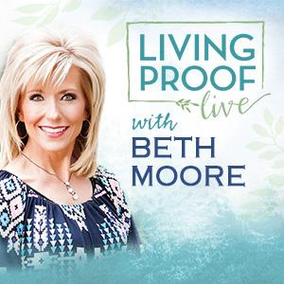
NURSERY – available for children age 0 to Kindergarten
Becky Yount

Hostesses for December Ushers for December
Dianne Lindemann, Shelia Waggoner, Kenny Merrell, Jimmy Miller,
Michael & Peggy Hammonds Wayne Marecle, Joe Daniel

Immediate Need Prayer List
Prayer & Request Information

(Please complete name & address information on reverse side)

❑ I would like to speak with the Pastor.

❑ I would like more information on this church.

❑ I have Prayer Requests or Needs

Date:

Permission to Publicize:
Church Bulletin  Yes  No
Email Prayer Chain  Yes  No

Prayer Request:

Prayer For
Name
Address
Phone

Given By
Name
Address
Phone
Please Contact By

❑ Card  Phone  Visit

Comments

Pray for Bobby Coffey – He is in the hospital with a swollen jaw

Pray for Jerry Watkins (friend of Hugo Breithaupt) – He is dealing with cancer

